Colonoscopy Frequently Asked Questions

Why are colonoscopies done?
A colonoscopy is a type of endoscopy, meaning it uses an endoscope to examine your digestive tract to investigate and diagnose disease. Your physician may need a colonoscopy to:
- Look into symptoms like pain, nausea, difficulty swallowing, bleeding and changes in bowel habits.
- Further investigate findings in a physical examination like tenderness, a mass or signs of nutritional deficiency.
- Explore the digestive tract after lab results show a low blood count, anemia or other issue.
- Check into concerns if your personal or family medical history puts you at an increased risk of certain disorders.
- Screen for risk of disease and colorectal cancer.
Colonoscopy is the most effective way to find adenomas — colon polyps that are more likely to form into colorectal cancer. It also allows the gastroenterologist to remove any suspicious polyp. That’s why colonoscopies are done more than other, more limited endoscopic examinations (flexible sigmoidoscopy), colon X-ray (barium enema) or chemical testing for invisible traces of blood in the stool (fecal occult blood testing, immunochemical or DNA testing like Cologuard).

Why do I need a colonoscopy if I feel fine and nothing is wrong?
Colon cancer is the third leading cause of death in the United States, but highly preventable. Colorectal cancer usually has no noticeable symptoms until advanced stages and then it’s much harder to treat. Detecting and removing polyps greatly reduces the likelihood of developing colorectal cancer in the future. If cancer is present, detecting it early before symptoms occur can increase your chances of survival.

Are colonoscopies safe?
Colonoscopy is a safe, low-risk procedure when performed by a well-trained physician. At Nashville Gastroenterology and Hepatology and Southern Endoscopy Center, all of our gastroenterologists are highly experienced and have undergone specialized training in order to provide high-quality, safe colonoscopies. Studies show that colonoscopies performed by an experienced gastroenterologist had a 65% reduction in risk for colorectal cancer mortality (death), compared with 45% when performed by a surgeon.

We also have extensive safety policies in place to ensure there are no infections and follow strict COVID-19 precautions.

Screening Colonoscopy Guidelines

When should I have a screening colonoscopy?
Screening colonoscopy exams are recommended for men and women starting at age 45. If you have a family history of colon cancer or polyps, screenings may start at an earlier age. Individuals with other conditions such as Crohn’s disease or ulcerative colitis are recommended to have more frequent screening.

Do I just need one colonoscopy exam and then I’m done?
For men and women without a family history or other risk factors, a screening colonoscopy should be repeated every 10 years. Should your physician find or remove polyps during your screening, you may be asked to return sooner than 10 years based on what type of polyp was removed. Age is one of the biggest risk factors for polyp formation and colorectal cancer, so that is another reason you may need to get your next colonoscopy sooner.

Who’s at average risk of colon cancer?
Guidelines have been developed as a way to make recommendations for screening colonoscopy based on known risk factors for colorectal cancer. The risk factors used for this “risk stratification” are age, family history of colorectal cancer and past history of colorectal adenoma or cancer. Risk stratification is not an exact science, but the guidelines are based on the known characteristics of colorectal cancer and the opinions of knowledgeable experts.
You’re considered average risk if you don’t have:
- Family history or personal history of colorectal cancer or colorectal adenomas
- Complaints about your bowels (passing blood with a bowel movement, recent change in bowel habit, unexplained weight loss or abdominal discomfort)
- Findings on physical examination suspicious for an abnormal growth in the rectum or mass in the abdomen
- Unexplained iron deficiency anemia

What’s considered a family history of colorectal cancer?
It’s important that you talk to your primary care provider if you have a family history of colorectal cancer or adenomatous polyps to see when you should schedule your colonoscopy. If someone in your family has had colorectal cancer or adenoma, you’re at higher risk for getting those too. There are also several known genetic traits that may be inherited which increase the risk for development of colorectal cancer.

Colon Polyps

What are colon polyps?
Colon polyps, or colorectal polyps, are noncancerous growths in the lining of your bowel. They are most common in adults over 45 years of age and in individuals with a family history of polyps. No known cause exists for why we develop polyps, but if not removed, some polyps can develop into cancer.

Are all colorectal polyps the same?
Polyps are not the same. Two common types exist: hyperplastic or adenomatous. Hyperplastic polyps are not at risk of developing into cancer. Adenomatous polyps, however, are a risk factor and thought to be the origin of almost all colon cancers. Many adenomatous polyps will not turn into cancer, but it’s not certain which ones will or will not, so removal is recommended for any polyp found on colonoscopy. Any polyps found and removed during colonoscopy will be sent to the lab for evaluation. Your physician will let you know the type of polyp removed and when to follow up with your next colonoscopy.
Will I be awake during my colonoscopy?
Patients will receive a sedative that makes them feel relaxed and drowsy. They are very comfortable and do not have much recollection of their colonoscopy.

How do I prepare for my colonoscopy?
Preparation involves a diet of clear liquids for about a day, and medications to cause diarrhea. Your gastroenterologist will give you specific guidelines about preparation.

What if my preparation for my colonoscopy isn’t thorough?
The goal of your prep is to have only clear/yellowish fluids in your large intestine so that your gastroenterologist can see the walls of your colon.
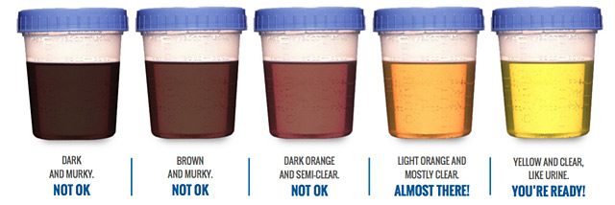

Fecal matter in your colon makes it harder to examine and therefore harder to find any polyps. If your preparation doesn’t seem to be working, call us.

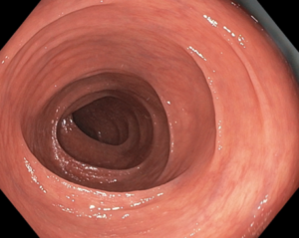
Good colonoscopy prep

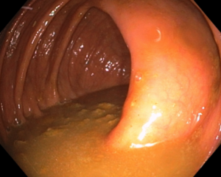
Poor colonoscopy prep

How long is the procedure?
The preparation is the hard part, compared to the procedure itself. A routine procedure takes about 20 to 30 minutes. Patients usually spend another 30 or so minutes in the recovery room as the sedative wears off.

Does it hurt?
In general, the colonoscopy is a painless procedure. Your bowel’s lining is not sensitive to cutting or heat so colon polyp removal is painless. Some patients may feel some temporary discomfort such as cramping and gas pain. While uncommon, some individuals may experience bleeding from the site of polyp removal, but this usually can be stopped during the colonoscopy. Rarely, a bleeding polypectomy site will require more urgent intervention at a hospital.

Colonoscopy Recovery

Why can’t I drive myself home or take a taxi or Uber?
When you receive sedation for your procedure, you are considered legally impaired. To ensure your safety, you must have a responsible adult and licensed driver to drive you and ensure you make it into your home. Because sedation can impair your judgment and reflexes, you may not drive or work for 12 hours after your procedure.

Can I eat after my procedure?
Yes! You may experience some mild nausea or feel groggy after your procedure. You also may not have a full appetite, but you may eat. We advise that you avoid greasy or spicy food right away to avoid nausea or upset stomach. We prefer you pick a light meal.

When will I have normal bowel movements after the procedure?
Because your bowel was completely emptied and you did not eat solid food a day before your procedure, you may not have a normal bowel movement for a couple days. This is nothing to be alarmed about.

Can I work the next day after my colonoscopy?
Yes, life returns to normal the day after your procedure. You will be able to work, exercise, eat and drive as you normally do.

